Department of Computer Science and Engineering

BRAC University

CSE 260: Digital Logic Design

Experiment # 6

Implementation of 4-bit Magnitude Comparator

- Draw the circuit that will act as a Magnitude Comparator. Your circuit should be able to compare two 4 bits number
- Implement your circuit (for two 4-bit numbers)

Theory:

The comparison of two numbers is an operation that determines if one number is greater than, less than or equal to the other number. A magnitude comparator is a combinational circuit that compares two numbers A and B and determines their relative magnitudes. The outcome of the comparison is specified by three binary variables that indicates A>B, A=B, or A<B.

The algorithm is a direct application of the procedure a person uses to compare the relative magnitudes of two numbers. Consider the two numbers A, and B, with four digits each. Write the coefficients of the numbers with descending significance as follows:
A=A₃A₂A₁A₀
B=B₃B₂B₁B₀
where each subscripted digit represents one of the digits in the number.

The two numbers are equal if all pairs of significant digits are equal i.e., if A₃=B₃, A₂=B₂, A₁=B₁ and A₀=B₀. When the numbers are binary the digits are either 1 or 0 and the equality relation of each pair of bits can be expressed logically with an equivalence function:

x_{i}=A_{i}B_{i}+A_{i}/B_{i}/, i=0, 1, 2, 3
where x_{i}=1 only if the pair of bits in position i are equal, i.e., if both are 1’s or both are 0’s.

The equality of the two numbers A and B is displayed in a combinational circuit by an output binary. This binary variable is equal to 1 if the input numbers A and B are equal and it is equal to zero otherwise. For equality condition to exist, all x_{i} variables must be equal to 1. This indicates an AND operation of all variables:

(A=B)=x₃x₂x₁x₀

To demonstrate if A is greater than or less than B, we inspect the relative magnitude of pairs of significant digits starting from the most significant position. If the two digits are equal, we compare the next lower significant pair of digits. This comparison continues until a pair of unequal digits is reached. If the corresponding digit of A is 1 and that of is 0, we conclude that A>B. If the corresponding digit of A is 0 and B is 1, we have that A<B. The sequential comparison can be expressed logically by the following two Boolean functions:

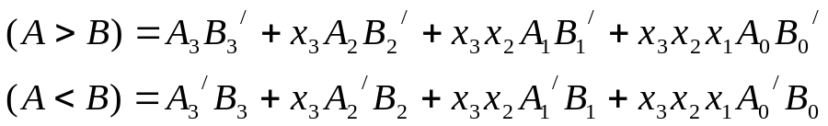

Report:
The report should cover the followings

- Name of the Experiment
- Objective
- Required Components and Equipments
- Experimental Setup (No need to draw the IC configurations)
- Results and Discussions .The discussions part must include the answers of the following questions:

  - Justify your designs of 4-bit Magnitude Comparator. Explain how it gives the results
  - A = B
  - A > B
  - A < B

- What changes have to made in your design to find the third result from any two of the three results (A = B, A > B, A < B)

Implement using NOR gate the following table:
A>B | A==B | A<B
0 | 0 | 1
0 | 1 | 0
1 | 0 | 0
1 | 1 | Undefined

